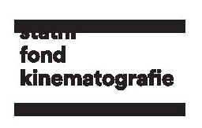
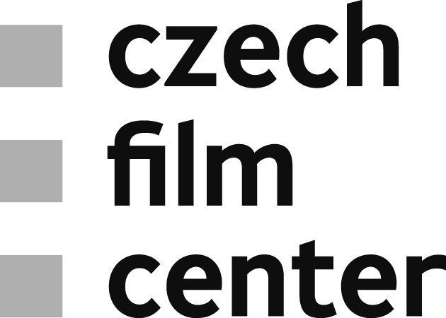

Czech Film Fund awarded €2,5 million for Production of Feature Films
The Czech Film Fund announced support for the production of 9 feature length fiction films totalling at EUR 2,516,000 (CZK 65 million). The highest amount – €588,235 – was granted to Zatopek by director David Ondříček and his production company Lucky Man Films.
Zatopek, directed and produced by David Ondříček, is based on Alice Nellis’s screenplay and tells the story of the Czechoslovak long-distance runner, three gold medals winner nicknamed the “Czech Locomotive”, at the 1952 Summer Olympics in Helsinki. Sports, as well as the fateful socio-political perpetuals, are reflected in the personality of Emil Zátopek. The iconic historical figure becomes a dramatic human "coloured" character.
The Council gave the second highest point evaluation to the project Mistakes of Jan Prušinovský, screenplay written by Roman Vojkůvka. A story of Ema and Tomáš, portrayed as a romance that needs to overcome lapses from the past of one of the protagonists, is produced by Ondřej Zima (Offside Men). The Fund Council appreciated the clear interpretation, the readiness of the project, and notably the experience of the director who, despite the challenging subject, can attract audiences, and granted the film with €274,509.
The amount €392,157 was awarded to both feature project Bourák (dir. Ondřej Trojan) and Snake Gas (dir. David Jařab). The latter, produced by Viktor Schwarcz (CINEART TV Prague), takes us onto an adventurous journey inside the main character’s soul and all dark corners it may encapsulate. On this exciting flashback, the protagonist will attempt to overcome frustrations and discover his most hidden instincts and desires. Bourák, on the other hand, represents a less metaphorical flashback and takes us into the „raw“ 1990s, accompanied with rockabilly sounds. The movie directed and produced by Ondřej Trojan (Total HelpArt) is inspired by actual events from the young years of the star screenwriter Petr Jarchovský and Trojan himself.
Supported projects also include a black comedy/thriller Terrorist by Radek Bajgar produced by Petr Erben (Logline Production), that received €78,631 from the Council. The same amount was granted to the adaptation of Iva Procházková’s young adult book Orange Days, directed by Ivan Pokorný and planned as Czech-Polish-German co-production, with the Czech producer being Daniel Severa (Daniel Severa Production). Finally, Silent Companion by Pavel Göbl received €313,725 (produced by CZECH FILM), the historical drama Principle Kriegel or the Man Who Stood in the Way by Ivan Fíla, production of Bio Illusion, was granted generous €392,157 and the joint project of Viktor Tauš and Beata Parkanová Scream Is a Beautiful Song sealed off the list of supported projects with the amount of €39,216 (produced by HEAVEN’S GATE).

