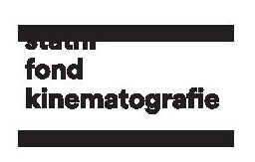
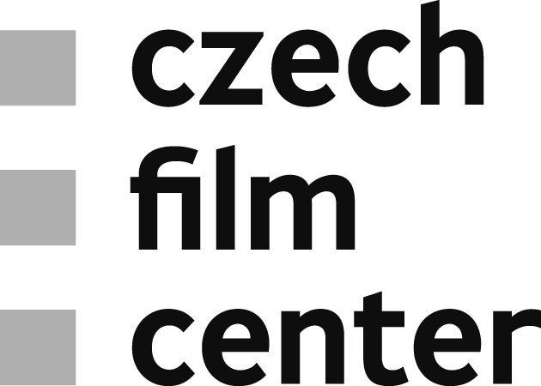

Czech Film Fund Announced Support
for 8 Minority Co-productions and 6 Animated Films Totaling €923,000
On October 9, the Czech Film Fund announced support for minority co-productions with the sum of CZK 20 million (€ 769,230). From the total amount of 25 projects that applied for support, 14 projects were selected at the initial stage and finally, 8 projects were supported. The amount and quality of the applications confirms the positive trend for the Czech film. It is also apparent that now, more than ever before, Czech producers seek and are capable to build strong ties with partners from abroad, be it Slovakia, Poland or France. On the same day, the support for development of animated films was announced. All together 6 projects – 3 features and 3 shorts – were supported with the total amount of CZK 4 million (€153,846).
Minorities
The highest evaluation of the Board and the amount of €173,077 was granted to the Slovak-Czech project Spisovatel directed by Martin Šulík and produced by IN Film Praha on the Czech side. The story about inner fights, emptiness and lack of inspiration of an ageing writer impressed the jury not only with an elaborated plot, but also with the cast consisting of A-class Czech actors, such as Miroslav Krobot or Oldřich Kaiser.
The second highest amount was granted to the Polish-Czech-Slovak fairy tale Kaytek the Wizard produced by love.Frame on the Czech side. The project that applied for the third time within the minority support scheme, finally received 100% of the desired amount (€134,615). Only slightly behind in financial support is another film for the younger audience, an adventure where kids are the ones saving grown-ups. Majority Polish Black Mill, co-produced by Czech 8Heads Productions received the support of €119,231.
Among further supported projects there are three co-productions with Baltic countries: an auteur film of the Latvian director Dāvis Sīmanis The Year Before the War (Czech co-producer Produkce Radim Procházka) that received the support €110,577, majority Lithuanian post-war drama In the Dusk, (directed by Šarūnas Bartase and co-produced by SIRENA FILM) that was awarded the amount of €115,385 and a Latvian documentary Soviet Man (dir. Ivo Briedis) with 20% of Czech participation through the co-producer Frame Films that was granted €20,192.
A Slovak- Hungarian-Czech drama Power, which again casts Miroslav Krobot among others, received the amount of €76,923. Directed by Mátyás Prikler and produced by Negativ on the Czech side, the story will focus on the dark mechanisms of power in Slovakia. Support was also granted to an animated debut A Carousel of a Belgian creator Jasmine Elsen (Czech production BFILM cz). Apart from the classic animation, the film will introduce stop-motion sequences, which will be fully conducted in the Czech Republic, hence the assigned support of €19,231.
Development of Animated Films
The highest sum of €46,154 went to the film Rosentaal produced by MAUR film. Rosentaal is a story inspired by the adventures of Jan Eskymo Welzl and partially impacted by the tradition of Karel Zeman and Jules Vernes. It starts with depicting a 16-year old orphan setting off on his exciting road trip through life filled with danger and struggles. The film is going to be produced with the use of a new animation technology that is being developed at Czech Technical University under the supervision of Daniel Sykora.
The second highest support of €34,615 was awarded to the feature Golem that has been in development for more than 25 years, newly taken over by Hausboot Production. The Jury agreed that the project of the director and artist Jiří Barta has significant potential mainly due to its experimental and exceptional characteristics, and with a new, elaborated plot is expected to result into a high-quality auteur film. The last feature animated film supported by the Fund with an amount of €23,077 was Michaela, inspired by Miloš Urban’s book of the same name. A horror with erotic and religious elements is going to be developed by the production company KABOS Film & Media.
Among short animations, the highest amount of €25,000 went to a VR project Dopis od srdce (A Letter from the Heart), produced by BFILM.cz. The film might be eventually also transformed into a 2D format. Although a minority, the project impressed the Jury with its innovative approach, artistic value and ethical message. Finally, two other animated shorts, Bábovka of a multiple award-winner Kateřina Karhánková (produced by MasterFilm) and The Little Odyssey (produced by k-pictures) received the support of €15,385 and €9,615 respectively.

