Press release. Prague, October 17, 2017

VĚRA CHYTILOVÁ at DocLisboa
The most extensive retrospective of the Czech film icon
presented at DocLisboa in Portugal, October 19-29

Director Věra Chytilová (1929-2014) was one of Czech cinematography’s best-known figures. The director’s work, of which the experimental farce Daisies is particularly celebrated abroad, will be commemorated with an extensive retrospective at the DocLisboa festival (October 19-29), where some three dozen of her shorts, documentaries, and feature films will be screened.

The retrospective is organized by the festival in curatorial and financial partnership with the Czech Film Center.
Since her death in 2014, Chytilová’s work has screened around the world, for example at the London retrospective Defiance and Compassion (2015), which presented 13 of her films. But none of these exhibitions has been as extensive as the one to be presented at the DocLisboa festival. It will be the largest ever showcase of Chytilová’s films, giving visitors the chance to see nearly her entire oeuvre, from her first student film, Caterwauling (1960), to her last feature fiction film, Pleasant Moments (2006).

The full program of DocLisboa’s retrospective is available here:
http://www.doclisboa.org/2017/en/seccoes/vera-chytilova-retrospective/

“For me personally, Chytilová is above all a mysterious director whose work remains to be fully deciphered or even seen: an elusive and indefinable auteur. Her enduring legacy, comprising almost 20 features, follows an ever-changing stylistic trajectory,” says Boris Nelepo, film critic and programmer of the Chytilová retrospective at DocLisboa.
In recent years the festival has featured the work of such illustrious and groundbreaking directors as Peter Watkins, Frederick Wiseman, Želimir Žilnik, Johan Van Der Keuken, Chantal Akerman, Harun Farocki, Jean Rouch, Jørgen Leth, Marcel Ophüls, Joris Ivens, and Jonas Mekas.

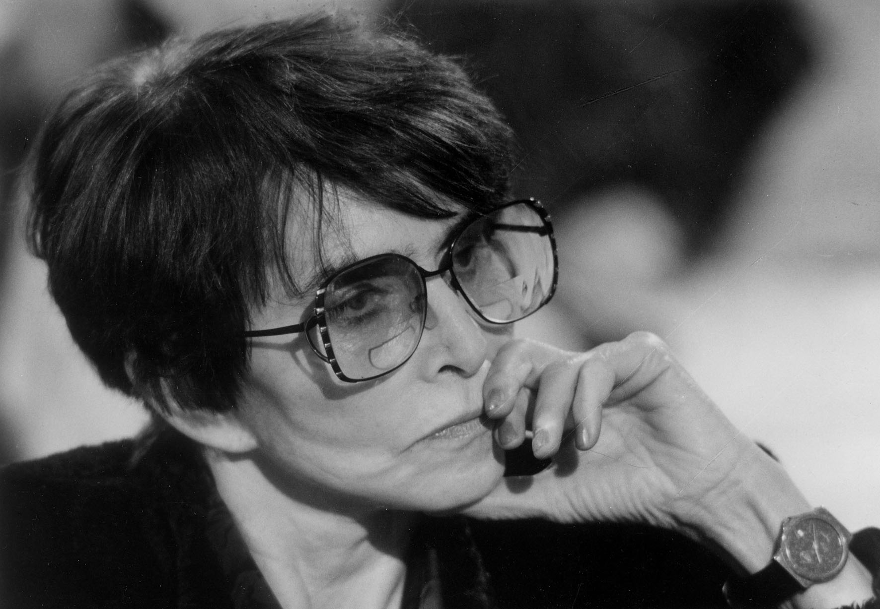
Chytilová was uncompromising, and also pioneering. She instilled her own ideas of morality and all the ways it could fail in filmmaking, while at the same time leaving a distinct mark and looking for new means of cinematic expression. Initially, her style was based on cinéma vérité, which influenced her first short films, Ceiling and
A Bagful of Fleas (presented together as A Bagful of Fleas by the Ceiling, 1962), and the feature film Something Different (1963), which combined documentary and fiction film. Chytilová was
a natural part of the Czechoslovak New Wave, alongside Miloš Forman, Jiří Menzel, Evald Schorm, and others. Each of them maintained their own style and poetics.

“The early, ‘vintage’ Chytilová is indebted to surrealism, symbolism, and the allegorical tradition. Dramatically different from her is the Chytilová of the 1970s and ’80s, one that reinvented herself, at no detriment to artistic integrity, as a virtuoso of slices of everyday life and whose chronicles still allow us
a glimpse into the Czechoslovak society of the time. Her crowning achievement of that period, Prefab Story, stands to this day as one of the most scathing, tragic, and perfectly crafted monuments to the communist project (here she, strangely enough, overlaps with Kira Muratova, whose late-period motifs Chytilová had largely anticipated). It only gets more interesting from that point on: a horror Wolf’s Chalet is followed by one of the world’s first movies about AIDS (Tainted Horseplay); then comes the subversive folk comedy The Inheritance or Fuckoffguysgoodday, so accurate in its portrayal of the country’s transition to capitalism; and finally, the radical feminist perspective of Traps is succeeded by Searching for Ester, the loving tribute to a close friend and coauthor,” says Boris Nelepo.
“This is why it is of great importance for us to present as thorough a retrospective as possible, including Chytilová’s documentaries, shorts, and made-for-TV films. Making sense of a decades-spanning career of such complexity is not an archivist’s task; on the contrary, Chytilová’s distinctive film language, ideas, and formal devices are future-oriented inasmuch as they help us gain a better insight into today’s filmmaking landscape,” ads Nelepo.

http://www.filmcenter.cz/en/news/1330-retrospective-of-vera-chytilova-at-doclisboa

Press servis:
Hedvika Petrželková
Czech Film Center
Národní 28, 110 00 Praha 1
+420 770 127 726, +420 776 167 567
hedvika@filmcenter.cz
www.filmcenter.cz; facebook

