Press release, Nov. 13th, 2017

Czech documentaries at IDFA 2017
Three new Czech documenatries have been selected for International Documentary Film Festival Amsterdam (IDFA), which takes place November 15 - 26, 2017. Nothing Like Before by Lukáš Kokeš and Klára Tasovská will have its world premiere in the Competition for First Appearance, Petr Horký's directorial debut The Russian Job has been selected for the Competition for Mid-Length Documentary and Vít Klusák's The White World According to Daliborek will be screened in the Masters section.

Nothing Like Before
Film by Lukáš Kokeš and Klára Tasovská, selected for the Competition for First Appearance, is a stylized documentary view into the life of present day teenagers living on Czech-German border – a geographic and social periphery in the middle of Europe. It portrays daily lives of 3 youngsters, students at one particular high school, and witnesses their transformation into mature individuals. It is the second documentary film of the creative duo after Fortress (CZ, 2012), which received the nomination for Lux Prize and also won the Czech Joy competition at Jihlava IDFF. The film was produced by nutprodukce in co-production with HBO Europe.
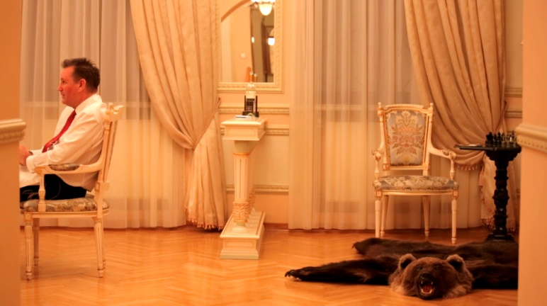
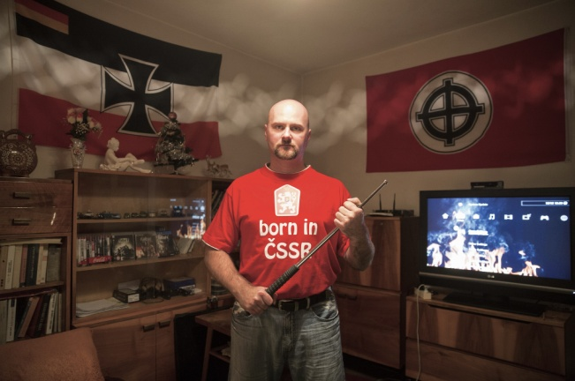
The Russian Job
The fate of a languishing Russian car factory, tagged to be brought back to life under new Swedish management, is the topic of The Russian Job, journalist Petr Horký’s cinematic debut selected for the Competition for Mid-Length Documentary. He came across the subject by chance when he was sent to the Avtovaz car factory, which produces the famous Lada cars, to write a report for a business publication.The film was produced by Krutart in co-production with Czech Television.
The White World According to Daliborek
In the Masters section will be screened Vít Klusák's latest documentary The White World According to Daliborek. The controversial portrait of a radical neo-Nazi Dalibor K. was premiered in the Documentary Competition of this year's Karlovy Vary IFF and the screening at IDFA will be its first international presentation. The film was produced by Hypermarket Film in co-production with Czech Televison, Peter Kerekes (SK) and BRITDOC Foundation (UK).
TRAILER
All three films have been supported in the various stages of develpment and production by the Czech Film Fund.
Docs for Sale
In addition, all three mentioned films and another four Czech and co-production films will be presented at the industry event Docs for Sale (November 17 – 23). A Marriage Story by Helena Třeštíková, produced by Negativ in co-production with Czech Television, the Latvian-Czech co-production D Is for Division by Davis Simanis, produced by Guntis Trekteris (LV) and Radim Procházka, the portrait of controversial former Slovak prime minister Vladimir Mečiar The Lust for Power by Tereza Nvotová, produced by PubRes (SK), and co-produced by HBO Europe and Negativ, and Batalives by Karolína Zalabáková and Petr Babinec, produced by Lukáš Gargulák, Cinebonbon.
Moreover, another Czech upcoming documentary will be presented at pitching session for TV professionals organized by the European Broadcasting Union (EBU). Satanic Girls: Women on the Move directed by Bohdan Bláhovec and produced by Anna Herza Tydlitátová, is a story about women, status and power in show business. The film follows several retired pop divas as they remember their wild rock’n’roll past, touching upon the topics of aging, relationships and selective memory.

Read more about Czech documentaries in the article published in the CZECH FILM magazine (Fall 2017) here.
Screenings of Czech films at IDFA:
The Russian Job
Industry & Press screening: Thu 16 November — 13:00 - 14:04, Munt 13 (Pashouders/ Industrie)
Fri 17 November — 18:30 - 20:03, Munt 10
Sat 18 November — 12:45 - 14:15, Tuschinski 4
Mon 20 November — 14:30 - 16:18, Tuschinski 6
Wed 22 November — 16:30 - 18:18, EYE Cinema 2
Sun 26 November — 16:00 - 17:18, Munt 13

Nothing Like Before
Industry & Press screening: Sat 18 November — 15:15 - 16:48, Tuschinski 3 (Pashouders/ Industrie)
Sat 18 November — 20:00 - 21:50, Munt 10
Tue 21 November — 18:00 - 19:50, Tuschinski 3
Wed 22 November — 13:00 - 14:35, EYE Cinema 1
Sat 25 November — 11:00 - 12:35, Munt 12
The White World According to Daliborek
Mon 20 November — 18:45 - 20:50, Tuschinski 2
Tue 21 November — 13:15 - 15:37, EYE Cinema 1
Wed 22 November — 20:30 - 22:35, Munt 11
Sat 25 November — 14:45 - 16:35, Brakke Grond Expozaal

Czech Film Center at IDFFA:
Vítězslav Chovanec
Festival Relations - Documentary & Short Films
vitezslav@filmcenter.cz
+420 778 487 864
/November 19-23/

http://www.filmcenter.cz/cs/press
Press servis:
Hedvika Petrželková
Czech Film Center/ Czech Film Fund
Národní 28, 110 00 Praha 1
+420 770 127 726, +420 776 167 567
hedvika@filmcenter.cz
www.filmcenter.cz; facebook

