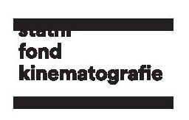
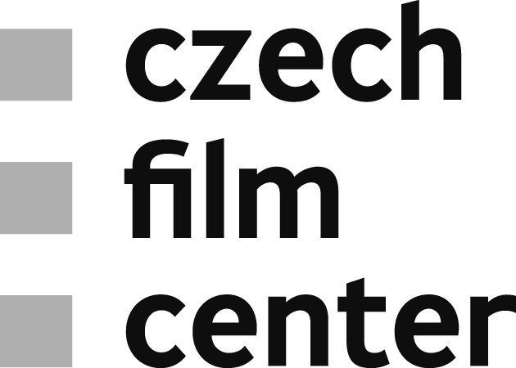

CZECH FILM SPRINGBOARD
Finále Plzeň 2018
The 31st edition of the Finále Plzeň Film Festival took place from 19 to 24 April 2018. A presentation of Czech films was open to a wide audience and was accompanied by the industry events for film experts and professional. Third edition of Czech Film Springboard was held within the Industry Days from 21 to 24 April and was organized by the Czech Film Fund – Czech Film Center in close cooperation with the festival. This year's program included two accompanying events open to the professional public, offering a unique opportunity to meet foreign film professionals and experts. Two more innovations were presented at the festival - a wider industry program dedicated to France and a newly mounted presentation of projects in post-production called Works in Progress.

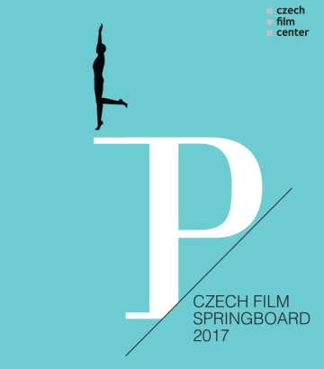
http://www.filmcenter.cz/en/our-activities/project-development/czech-film-springboard
http://www.festivalfinale.cz/eng/filmmakers-and-media/ano/program-industry-days

WHO IS WHO Monday, April 23, 01:30 pm – 03:00 pm, Měšťanská beseda (Small Hall)
Informal meeting with the invited foreign film industry experts. The representatives of film festivals Göteborg IFF, Giornatte degli Autori, Tallinn Black Night Film Festival, BFI London Film Festival, Cottbus Film Festival, New Horizons IFF, Thessaloniki IFF, sales agents Film Republic, Slingshot Films, Pluto Films, training programs Torino Film Lab or EAVE and co-production markets CineMart, Baltic Event and Connecting Cottbus attending the festival presented their professional activities to the audience comprised of the film industry professionals.
FUNDING NEWS Monday, April 23, 03:30 pm – 04:30 pm, Měšťanská beseda (Small Hall) Moderated discussion about funding opportunities and co-producing in Central and Eastern Europe. The representatives of national funds of Estonia, Slovenia and Iceland gave the short overviews and answered the concrete questions on accessing financing in their countries.
PANEL DISCUSSION: CZECH-FRENCH COOPRODUCTION AND CO-OPERATION IN FILM AREA BETWEEN FRANCE AND CZECH REPUBLIC Tuesday, April 24, 10:30 am – 12:00 am, Měšťanská beseda (Saloon Primátor) The aim was to present some of the recent co-productions (minority or majority Czech) and incentive French projects shot in the Czech Republic, how the cooperation worked, a sort of case studies on the financing and production of these projects. French and Czech co-production duos – producers involved in the incentive projects was presented to discuss the topics. A moderator panel explored the different aspects of Czech-French connection.
WORKS IN PROGRESS Monday, April 23, 10:00 am - 12:00 am, Měšťanská beseda (Small Hall) New added presentation of projects in post-production answered the demand of present experts, especially sales agents and festival programmers, for interesting film projects ready to release. Five feature-length fiction film projects in post-production were presented as a teaser of 15-20 minutes.
ABOUT CZECH FILM CENTER: The Czech Film Center was established in 2002 to represent, market and promote Czech cinema and film industry and to increase the awareness of Czech film worldwide. CFC is the national partner of important international film festivals and co-production platforms, taking active part in selection and presentation of Czech films and projects. It provides tailor-made consulting, initiates and co-organizes numerous pitching forums and workshops, prepares specialized publications, and network on international level.
CFC works closely with producers on film development and release strategies. For promising projects, CFC organizes specialized pitching events and cooperates with international experts and trainers to help filmmakers develop their film stories.
CFC is an important source of up-to-date information about Czech Cinema, new legislation in the field and funding possibilities in the Czech Republic. CFC owns and maintains unique know-how and contacts, mediates connections between Czech and foreign film industry, actively creating networking opportunities for film professionals. The rich publishing activity includes unique regular and occasional publications featuring new films, interesting filmmakers and current topics on the Czech film scene.

Press servis:
Helena Sedmidubská
Editor&External Communication
Czech Film Center
____________________________
Národní 28, 110 00 Praha 1
cell phone: +420 777 501 562
e-mail: helena@filmcenter.cz
www.filmcenter.cz
facebook

